# 

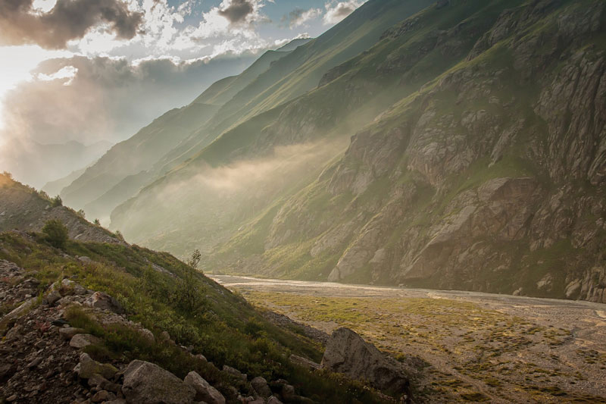

© 2022 Rolling Rapids • Sister A • WDD130-14

Site Plan

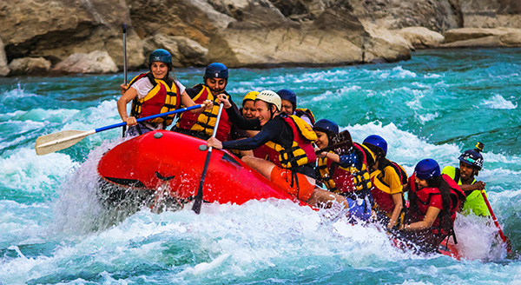

Have an Adventure

Make Memories with Rolling Rapids

**Our Trips**

**Rivers Camping** **Rapids**

More Than Just The Thrill

Enjoy the breathtaking scenery. From valleys, meadows, canyons, and high peaks; it's way more than just the rapids. It's a great way to get away from it all and relax amongst all the beauty of the great outdoors.

**Our Trips**

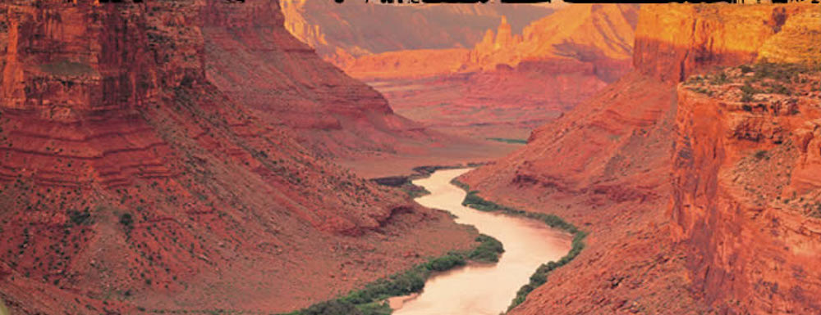

© 2022 Rolling Rapids • Sister A • WDD130-14

Our Rivers

Grand Canyon, Arizona ( Class I - V )

The Colorado River runs for 278 miles, and flows through the most spectacular canyon on earth. Along the journey, the river encounters famous stretches of whitewater, beautiful side canyons, and incredible views around every turn. Many adventurers consider their Grand Canyon rafting tour the adventure of a lifetime.<br> There are a wide variety of trips to fit any schedule and group. Calm - moderate for families .... Moderate to crazy wild for the fearless and trips fun from 2 day to week long trips. Rafters must hike into the Grand Canyon to reach the river. (different start points depending on which trip you choose. You then raft through the heart of the Grand Canyon. Ride the biggest Grand Canyon Rapids. The trip ends with a hike back to the rim of the canyon. This trip offers plenty of time for hiking and exploring and enjoying the company of other rafters in the campsites at night. c

Yellowstone, Montana Gallatin River ( Class I - I I I )

Welcome to one of the premier river rafting destinations in the west! The Gallatin offers you the chance to view incredible scenery and paddle through some fun, challenging, and continuous whitewater. We offer different stretches of river for a variety of skill levels. Depending on your expectations, correctly timing your trip can be the most important factor. Do you want to raft the infamous, class IV Mad Mile? The water is highest early in the season, then tapers off as the summer progresses. <br>Looking for a mellower ride? Check out the upper Gallatin any time or the Lower Gallatin later in the summer. Our Gallatin River office is located on Highway 191 between Bozeman and Big Sky, north of West Yellowstone. This is where you will meet for our Gallatin or Madison River Trips.

Pick a trip and let's get rafting!

Okay, so as you can see, we have a pretty large variety of trips to fit any skill level, any price level, and any time level. We invite you to come and check us out. You will have the time of your life and make memories that will last forever. I guarantee you that you will have a great time and will probably want to take another trip after you raft with us.

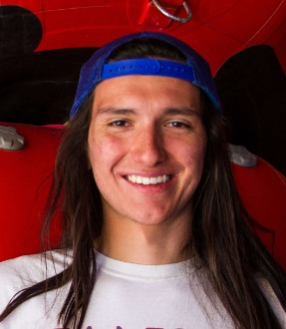

© 2022 Rolling Rapids • Sister A • WDD130-14

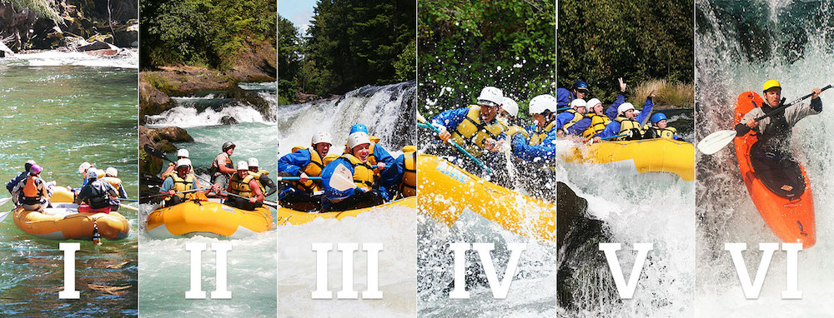

**Meet Our Rapids Guides**

Britt the Fit

Cam the Slam

Nate the Great

We Are Waiting to Hear From You!

Sister A's Roaring Rapids was founded in 1998 in Northern California with 2 rafts and 2 tour guides. It started as a small family operation and has now expanded to a staff of 16 tour guides, 25 rafts and spans 5 states. With a love for the great outdoors and mother nature's power, we have rapids and other nature tours 52 weeks per year. It's always rapids time, somewhere. We invite you to look at what we have to offer and take a chance on the greatest experience you will ever have... Come join us by Roaring on the Rapids with us soon.

Reserve Your Trip Now

Phone: 866-667-8411

funrides@roaringrapidsRus.com

We Proudly Take: